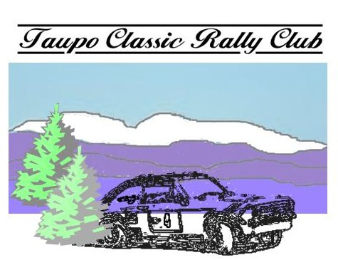
www.classicrally.org.nz secretary@classicrally.org.nz

President:
Bernie Keith
027 889 8880

Secretary:
Colin Gibson
021 267 9034

You know the story – a few enthusiasts shooting the breeze after a rally – one comment led to another and here we are – forming a predominantly 2 wheel drive motorsport club to continue the tradition of the ‘good old days’ of rallying. A number of Central North Island car club members have got together to form the club with the aims of running an annual 2wd Classic rally, and providing some entry level classes for progression to rallies by promoting tarmac or gravel events such as gravel sprints and rally sprints.

Members of Taupo Classic Rally Club have a passion for 2wd vehicles from a by-gone era and wish to have some fun events while preserving forest venues for future use.

The club will also provide some social events given our location in the north island.

The annual membership fee will be kept low and those helping or competing in club events will get a rebate on their annual membership fees.

The Club is an incorporated club and has affiliation to MotorSport NZ.

The annual fee ($35.00 per person) will apply from 1st January to 31st December

Enquiries can be made via the website: www.classicrally.org.nz where you can download a membership application form, or email secretary@classicrally.org.nz

